

Architectural and engineering specifications

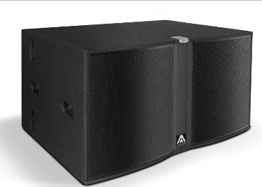
JK218W2

• The subwoofer loudspeaker system shall have two ferrite magnet 18-inch low frequency transducers loaded in a bass-reflex tuned enclosure. Each transducer shall be rated at a nominal impedance of 8 ohms.

• The usable bandwidth (with external processing) shall be 28Hz to 110Hz (-10dB).

• SPL, measured at 1W and 1m under free field conditions shall be 101dB.

• Maximum continuous musical program shall be 2000W.

• Enclosure shall be bass-reflex type with some lateral triangular ducts.

• Enclosure cabinet construction shall consist of birch plywood with a black textured finish. Dimensions shall be 1070 mm (42,1 inch) wide, 572 mm (22,5 inch) high, 805 mm (31,7 inch) deep. Enclosure weight shall be 77,8 Kg.

• The front enclosure shall be protected by two steel grilles with acoustically transparent foam. The grilles shall be secured via screws to keep it in place when facing the cabinet downwards.

• The cabinet shall feature some M8 fixing points to screw optional wheels.

• Electrical connections shall be made via one of the two 4-pole NL4MPR Speakon connectors with the following configuration: +1/-1 signal input, +2/-2 disconnected.

• The loudspeaker system shall be the Master Audio® Joker JK218W2.

